

DOCUMENT 2

SSMP

Sports Safety Management Plan

Version 2.0
April 2025

Page intentionally blank.

Amendment Information

Version | Release Date | Issued By | Details of Amendment
2.0 | Apr 25 | Jenkins, CL | Re-write & name change from Air Safety Management Plan (ASMP) to Sports Safety Management Plan (SSMP).

Contents
Amendment Information 3
Introduction 6
Overview 6
Safety Vision 7
Statement 7
Objectives 7
Our Just Safety Culture 7
Scope of Sporting Activity 8
Tolerable and ALARP Statement 8
Air Safety Accountability Structure 8
Regulatory Documents 9
Compliance with the Health and Safety at Work Act 1974 (HSAW) and National Governing Body (NGB) regulations. 10
RAFSA Responsible Person 10
Safety Assurance 10
Association Level 10
RAFSA School/Club Level 11
NGB Insurance/Liability 11
Managing Risk 11
Flight Safety Officer Requirement 11
Battle Rhythm 11
Risk Assessments 12
Threat and Error Management 12
Sport Safety Management Responsibilities 13
Emergency Action Plans 13
Medical & Emergency Response Planning Considerations 13
Medical Planning AIR TLB Requirements 13
Emergency Response Planning CAA Requirements 14
Relating CAA requirements to MOD Provision 14
Event Organisers 14
Accident, Incident and Hazard Observation Reporting 15
Air Safety Meets Functional Safety 15
Atmosphere 15
Reporting Means 15
Notification 16
New Members. 19
Individual Member Responsibilities 19
Personal Fitness and Medical Conditions 19
Equipment, including aircraft and anything carried therein 19
Dynamic Risks 19
Climatic Injury 19
Heat Illness 19
Cold Injury 20
Safeguarding 20
Public Military Events 20
Access to SSMP / Retention of Data 20
Reference Documents 20
Amendment Process 21
List of Annexes 21
Annex A to RAFSA ASMP. List Of MAA, CAA And EASA Mandatory Reportable Occurrences. 22
Annex B to RAFSA ASMP. RAFSA Dynamic Risk Assessment (DRAM), v3 March 25. 25
Annex C to RAFSA ASMP. The RAF Sport Incident Management Order and Notification Flow Diagram. 26
Annex D to RAFSA ASMP. FAiR model, as outlined in the MAA Manual of Air Safety. 29

Introduction
1. We are all in this together. Safety is central to the delivery of activity for RAF Sport Aircraft and requires people at every level to embrace our Just Safety Culture and practises. Sustainable, Safe RAFSA operations with approximately 750 practising pilots and 50 aircraft is no mean feat and is only the result of the integrity, professionalism and hard work of all those involved.
2. Aviation has inherent risks not found in routine activities. For example, while a car with an engine problem can simply coast to the side of the road in relative safety, an aircraft with the same problem may have to complete a forced landing. This extra degree of risks has made aviation one of the most safety conscious disciplines since its inception in 1903.
3. However, there is always room for improvement. In recent years our understanding of how accidents and incidents happen has improved. More emphasis is now placed on the causal factors involved and the organisational factors that contribute to errors being made. Organisational factors include how an organisation operates, how it sets out its procedures, how it trains its staff and what level of importance it gives to safety issues identified within the organisation.
4. It is the policy of the Air Force Board to give as much practical encouragement as possible to RAFSA Flying Schools/Clubs, iaw RA1010. The objective of RAFSA is to provide RAF personnel with flying instruction and flying in light aircraft as economically as possible, thus encouraging air mindedness and good airmanship. RAF Sport Aircraft is the associating body for the Service flying schools/clubs in the UK in that it acts as an association for the independent member schools/clubs that are affiliated with it.

Overview
5. The RAF Sport Aircraft (RAFSA) Association Sports Safety Management Plan (SSMP) has been formulated to define the Health and Safety (H&S) responsibilities and actions of all eligible personnel organising and participating in Sport Aircraft activities, it is to be read in conjunction with AP3415 Sport in the RAF and also relates to the documents at para 84 of the SSMP.
6. The RAFSA SSMP is applicable to full members of RAFSA which includes all Tri-Service Regular and Reserves Forces, as well as International Forces eligible under the criteria listed in JSP660 Sport in the MoD.
7. Associate clubs of RAFSA and their members should adhere to the principles and requirements laid out within this SSMP.
8. RAFSA comprises flying schools, clubs and associated clubs. All are Declared Training Organisations (DTOs), lead by a named Responsible Representative/Accountable Manager (AM) under the regulation and assurance of the Civil Aviation Authority (CAA). In addition, RAFSA, supported by the RAF Central Fund/Charitable Trust, oversees delivery of the Junior Ranks and Officers’ Pilot Scholarship Scheme (JROPSS) and Introductory Flight Scholarship (IFS). RAFSA organises competition championships supported by the appropriate National Governing Body (NGB), such as aerobatics and air racing.
9. The RAFSA SSMP applies to any RAFSA activities, both on and off duty, including all associated activities.
10. The RAFSA SSMP interacts with the Directorate of RAF Sport (DRS) Safety Management System (SMS) and AP 8000: AIR TLB Safety & Environmental Protection Policy (S&EPP).
11. RAFSA activity is governed by a NGB iaw JSP660; the overarching NGB is the CAA, which delegates oversight of specific activity to sub-NGBs. Examples of sub-NGBs are the Light Aircraft Authority (LAA), for permit-to-fly aircraft, and the British Aerobatics Association (BAA). Oversight of aerodromes used by RAFSA aircraft may be regulated by the Military Aviation Authority, with the Head of Establishment (HoE) holding a duty-facing responsibility to the RAFSA Responsible Person (RP) and AM.

Safety Vision

Statement
12. To support and assure the safety of all RAFSA activity in order to afford servicemen and women, regardless or rank or trade, the opportunity of learning to fly safely at the lowest practical cost.
13. We must recognise that our activities are inherently risky. However, we can work to manage and treat that risk to a level which is As Low As Reasonably Practicable (ALARP) and Tolerable.

Objectives
14. RAFSA shall achieve its Safety Vision through the following objectives:
- Support our Accountable Managers and Heads of Training to meet their roles and responsibilities, as required by the UK CAA.
- Support our Flight Safety Officers to meet their roles and responsibilities.
- Ensure an accessible, tailored, consistent reporting mechanism, at the point of use, across RAFSA.
- Assure RAF Duty Holders (DH), in a DH-facing context, that RAFSA schools/clubs meet the requirements of the aviation authorities they are accountable to.
- Educate RAFSA and Royal Air Force personnel on the responsibility and accountability structures applicable to RAFSA flying operations.
- Facilitate communications and sharing of Best Practice amongst our schools/clubs.
- Oversee reporting and support investigations, to understand both the individual and common risks held by our Accountable Managers.
- Provide 3rd party assurance at the request of a school/club AM, the RAFSA Chair, or other appropriate authority.
- Engage with civilian and military organisations to represent RAFSA and support Safety improvement in the wider aviation community.

Our Just Safety Culture
15. Sustainable, Safe RAFSA Operations require people at every level to embrace our Just Safety Culture and practises. Our Just Safety Culture is one in which persons are not punished for actions, omissions or decisions taken by them that are commensurate with their experience and training, but in which gross negligence, wilful violations and destructive acts are not tolerated. We acknowledge that the overall majority do not turn up to fly with the intention of doing harm.

Scope of Sporting Activity
16. The RAFSA SSMP applies to a specific set of General Aviation (GA) flying activities as agreed by the association and the RAFSA RP, which are in turn governed by the AM of each flying school/club. It does not cover the conduct of other General Aviation activities undertaken by personnel.
17. RAFSA activities that attract duty status are formally promulgated, e.g. competitions. Where not formally promulgated, RAFSA activity will be conducted off-duty. Off-duty forms the majority of RAFSA activity.

Tolerable and ALARP Statement
18. All health and safety risks are at least As Low As Reasonably Practicable (ALARP) and Tolerable. Tolerable is defined by the RAFSA RP as having an overall Risk Rating of no greater than MEDIUM.
19. The RAFSA RP declares that all health and safety risks are at least Tolerable and ALARP. This will be review annually, or upon a new RP taking post. The signature and date of RP RAFSA (below paragraph 85) is the formal record that risks for the RAFSA are Tolerable and ALARP.

Air Safety Accountability Structure
20. RAFSA schools/clubs operate in accordance with the UK Air Navigation Order (CAP393) and the extant CAA UK-Part FCL Declared Training Organisation (DTO) assurance framework. RAFSA aircraft are G-registered, COCO (Civilian Owned, Civilian Operated). As outlined in CAP 1637 (Guidance Criteria for DTOs), Club OiCs are the Responsible Representative (known as the Accountable Manager elsewhere in the Aircrew Regulation and other EASA Organisational requirements). The AM is legally accountable to the CAA for the safe operation of the DTO.
21. As a Service flying school/club, each has accountability to both the civil and military governance structures. The air safety accountability chain is civilian, however the RAF has a Duty of Care to ensure that sport conducted in its name is safe. The Head of Establishment (HoE) where a RAFSA school/club is located has a Duty-Holder Facing responsibility to provide a safe operating environment.
22. As stated by many before ‘Safety is everyone's responsibility’, which is encompassed in the RAFSA safety tagline We are all in this together. This can be seen in the following diagram (Figure 1 Safety Responsibilities) that ranges from RAFSA members to the UK Government. Every one of us could be found responsible for loss of life, therefore following correct procedure and reporting is paramount. For example, when operating from a military aerodrome, the MAA occurrence reporting requirements should be considered (this cannot be enforced as RAFSA aircraft are COCO). The MAA occurrence reporting list is more extensive than the CAA requirement list; a table indicating this is located at Annex A.
Figure 1 Safety Responsibilities
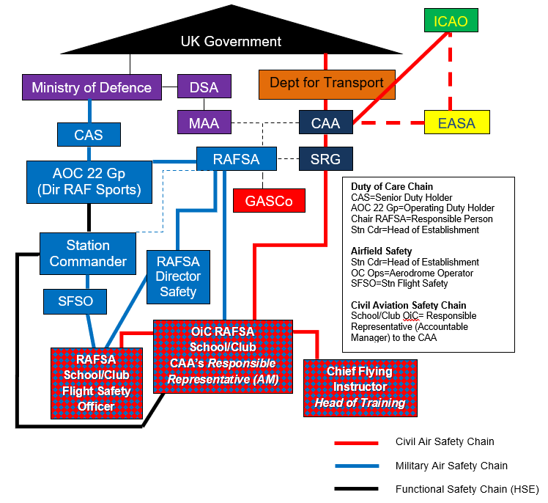

Regulatory Documents
23. The following documents are essential for RAFSA FO Responsible Representatives to understand their obligations:
- CAP1637: Guidance Criteria for Declared Training Organisations.
- CAP1059: Safety Management Systems: Guidance for small, non-complex organisations.
- UK Military Aviation Authority Regulatory Article (RA) 1010: - Head of Establishment Aviation Responsibilities and Aviation Duty Holder / Accountable Manager (Military Flying) Establishment Responsibilities.
- UK Military Aviation Authority Regulatory Article (RA) 2415: civil use of government aerodromes. Regulation 2415(1) Civil Use of Government Aerodromes has been incorporated into RA1010. Recreational Flying 2415(2) has been withdrawn as not deemed regulatory material.
- UK Military Aviation Authority Regulatory Article (RA) 1410: occurrence reporting and management.
- CAA Safety Plan.
24. A comprehensive list of reference documents is located in Sections 7 and 8 of RAF Sport Aircraft DOCUMENT 3 Code of Good Practice.

Compliance with the Health and Safety at Work Act 1974 (HSAW) and National Governing Body (NGB) regulations.
25. High Risk Sport in Defence is defined as sporting activity, conducted by approved personnel, which is categorised as having significant hazards and the potential for severe injury or death due to the inherent risks associated with participation. These sports typically involve, but are not limited to, one or more of the following elements: speed; water; risk of a fall from height, unpredictable environments; the use of specialised equipment; or single participation and where officials/coaches/assistance are at a distance and may not be able to intervene if safety is compromised. RAFSA will comply with the Health and Safety at Work Act 1974 by referring to JSP 375 and with the regulations set out by the NGB and Defence Safety Authority (DSA).
26. RAFSA undertakes routine activity and organises & partakes in events under a structure of NGB regulation, where the activity takes place at an established and licenced venue, under the oversight of Suitably Qualified and Experienced Personnel. An Accountable Manager is appointed, by agreement of the CAA, for each flying school/club. RAFSA will capture generic risks that are under their remit to mitigate. RAFSA will apply Specific and Dynamic Risk Assessment on an event-by-event basis. Regulation of RAFSA events are covered in the appropriate NGB documentation.
27. The RAFSA Director Safety will oversee Generic and Specific Risk Assessments for RAFSA activities on behalf of the RP. Dynamic Risk Assessment will be conducted by AMs, or their delegated SQEP, prior to activity.

RAFSA Responsible Person
28. The RAFSA RP operates under the remit of their Letter of Authority from Head of RAF Sport (AOC 22 Gp). The RP is required to undertake 1LoD at least annually, or on change of RP, and are liable for 2LoD by the Directorate of RAF Sport and 3LoD (if required) by the DSLR ATSR.
29. The RP is responsible for the formulation and management of the RAFSA SSMP. Specifically, they are to:
- Ensure that all personnel involved in the organisation, management, and participation of RAFSA personnel conform to the HSAW Act and the RAFSA SSMP.
- Not permit any activity to take place that is graded above a MED risk. Any events which could be considered above this will require further scrutiny and mitigation.
- Ensure a review of all risk assessments is undertaken, by the RAFSA Safety Mgr, at least annually and all post-accident/incident reviews on the appropriate safety systems are completed within the platform’s mandated timeframe.

Safety Assurance

Association Level
30. The RAFSA RP, or their nominated representative, will conduct 1LoD safety assurance by completing the Self-Assessment Questionnaire in AP3415 on at least an annual basis, or as directed by any of the agencies listed at para 28. The Self-Assessment Questionnaire will be reviewed at the association’s Annual General Meeting.

RAFSA School/Club Level
31. 1st Party Assurance (1PA). Yearly self-questionnaire, provided by RAFSA, to be completed.
32. 2PA. Assurance activities by the CAA regulatory processes. These include yearly reports submitted by the DTO to their nominated CAA representative, and 3-yearly inspections by their nominated CAA representative. RAFSA school/club membership status requires RAFSA to be sent copies of the DTO activity reports and inspection reports.
33. 3PA. Conducted biennially by RAFSA in the form of a questionnaire followed by a remote/in-person meeting where practicable. Conducted by the RAFSA Director Safety, SFSO, RAF Inspector of Sports Safety, or other appropriate body at the request of:
- RAFSA club/school AM (OiC)
- RAFSA Chair
- DH-Facing HoE
- RAF Sports Functional Safety DH Chain.

NGB Insurance/Liability
34. All participants are mandated to be RAFSA members (inc. temporary membership), holding the correct aircrew licence where applicable.
35. RAFSA aircraft are insured by each RAFSA flying school/club. RAFSA members are not automatically covered for personal accident insurance. Members are strongly encouraged to take out their own personal accident insurance cover.
36. Service Personnel are to note it is likely that compensation available via the Armed Forces Compensation Scheme will only be paid for injuries sustained during authorised activity, i.e. on duty (JSP765). Examples of activity which would not be considered would be leisure activities during periods when personnel are not required for duties associated with the core aims of a RAFSA duty event.

Managing Risk

Flight Safety Officer Requirement
37. All RAFSA school/club Accountable Managers (AMs) are to appoint a Flight Safety Officer (FSO). The requirement for an FSO is above what is required by the CAA, however it is best practice given RAFSA’s unique setup of host military establishments. The FSO position is recognised at military establishments, thus facilitating dialogue.
38. AMs and FSOs shall join the RAFSA Safety Committee (RAFSA Executive, school/club AMs and FSOs), whose aim is the sharing of best practice and relevant safety updates.
39. Each school/cub has an obligation to make RAFSA aware of matters arising. The following process will assure that RAFSA are being informed and that best practise is shared across the association.

Battle Rhythm
40. The FSO will update their section of the combined occurrences spreadsheet by COP 10th day of each month, for occurrences of the preceding month.
41. Monthly association dialogue. The RAFSA chairperson (or a nominated representative) will chair an online meeting 3rd Wed of the month in the evening 1800L (UK time) for 1 hour max.
42. The RAFSA Exec, club/school AMs (or a nominated representative) and the FSOs should attend the monthly dialogue. The first item on the agenda will be a review of the preceding month’s occurrences. This will confirm that the shared knowledge is the same as reality, whilst facilitating discussion of perceived lower-level hazards or occurrences which may have not reached the reporting threshold (Heinrich’s Triangle theory, often represented as an iceberg).

Risk Assessments
43. To manage risks within RAFSA the following levels of Risk Assessment will take place. Relevant examples can be found on the RAFSA SharePoint, in addition to seeking support from the RAFSA Safety Team or RAFSA Exec.
- Generic. Generic Risk Assessments will be captured in this SSMP utilising the RAF Form 7548, as required by the AIR TLB, using the appropriate Hazard Matrix. These will be standing risks that the RAFSA can reasonably provide mitigation for that are associated with all competitive and maintenance events.
- Specific. A Specific Risk Assessment will be completed for every event where it is identified that a specific event exists that is not captured under the generic risk assessment. Specific risk assessments will be captured on the RAF Form 7458 and be displayed at the event.
- Dynamic. Dynamic Risk Assessments are to be conducted before a day’s activities commence, to take account of varying local conditions, or during the activity at regular intervals or when circumstances dictate. This should be conducted at commencement of the day’s operation by a suitable representative of the AM and updated where necessary. The same applies to a RAFSA event hosted by a school/club or at a separate airfield, and should be detailed in the even-specific documentation. Ultimately, the AM/AM’s representative shall satisfy that it’s safe to operate on that day, specifically in that all personnel will be able to operate safely, using safe equipment.

Threat and Error Management
44. The RAFSA Dynamic Risk Assessment ((DRAM), v3 March 25 at Annex B)) should be completed for each sortie. The DRAM facilitates the practise of Threat and Error Management (TEM), which is the identification of any threats and errors specific to that sortie, required SOP deviations or additional controls and mitigations. The signature of the flight authoriser records that TEM has taken place via the DRAM. The school/club are to provide disposable copies of the DRAM, where a member may elect to record specific TEM considerations for their sortie.
45. It is a legal requirement to conduct a risk assessment for work-related activities (including sport). The degree of rigour applied by a manager to risk assess an activity is to be proportionate to the consequences of failure. The RP is to ensure that they conduct analysis on any potential gaps in MOD duty of care from NGB or other assessments. Five steps are applied to ensure effective assessment and management:
- The hazards that may affect the activity and are inherent within the activity are identified.
- Those who might be harmed, and the degree of harm, are identified.
- The identified hazards are assessed for their severity and likelihood, H&S risks are evaluated, and controls and mitigations are developed that reduce safety risks to ALARP.
- The result is recorded (as necessary) and implemented.
- The assessment is reviewed: in particular, controls and mitigations are monitored to determine their continuing effectiveness.

Sport Safety Management Responsibilities
46. Safe persons – RAFSA participants are expected to be medically fit to participate. It is the individual responsibility of ALL pers participating in RAFSA activity to declare ‘fit to fly’ at the start of the outbrief.
47. Safe Equipment – RAFSA participants can be responsible for checking and ensuring the safety of their aircraft and their safety equipment or could be delegated this task by a licenced person. RAFSA aircraft and safety equipment must meet NGB standards.
48. Safe Place – All RAFSA activity is to take place at a recognised airfield. The rules regarding safety management are to be adhered to for all activity in the association’s name, be that on or off duty.
49. Duty of Care Scope. The RP, through Flying School/Club AMs, retains duty of care throughout all activity undertaken under the auspices of RAFSA. Exercising this duty of care is reliant upon compliance with NGB regulation. Individual participants have ‘signed on’ to accept that they hold an individual responsibility to conform to the ‘Safe Person’ and ‘Safe Equipment’ elements and the NGB have provided the ‘Safe Place’. In most cases the NGB have established processes in place to provide duty of care over all participants, not just military personnel, and experience has shown that they do so to the highest standard.

Emergency Action Plans
50. Emergency plans will normally be specific to the site you are operating from and be within NGB mandates; each airfield will have a ‘crash plan’ and ‘actions in the event of an overdue aircraft’. Specific Event organisers must consider how emergency assistance can be sought at their location, the practicalities of evacuation of casualties and the implications of an incident on the rest of the event. RAFSA requires event organisers to specify emergency arrangements in their Admin Orders. The RAF Sport Incident Management Order and Notification Flow Diagram can be found at Annex C to this SSMP.

Medical & Emergency Response Planning Considerations

Medical Planning AIR TLB Requirements
51. Consideration of medical planning for UK activities is to be conducted at least annually, as part of the 1LoD process. Where events are being hosted by the Service, or significant numbers of spectators who are the responsibility of the Service are expected, the entire Population at Risk (PAR) is to be considered in this planning.
52. RAF Sport Medical Planning Considerations must be detailed in all Event and/or Admin Orders relating to fixture authority. Routinely no Service medical support is available for sporting events, in the UK all emergency medical support is provided by the emergency services by dialling 999. Emergency call handlers and Paramedics will dictate the best local or regional hospital to evacuate injured persons to.
53. For remote venues, Event Leads are to consider additional protection measures in their medical planning. Risk Assessments must assess and mitigate the risk of Climatic Injury and should be informed by any hosting venue resources. For Overseas Visits, Air Med Ops require 90 days’ notice to consider medical plans for Overseas activities and a Medical Plan must be submitted iaw HQ Air Medical Planning Guidance.

Emergency Response Planning CAA Requirements
54. The CAA requires a very specific set of emergency and medical services, for both units and equipment at NGB sanctioned and/or governed events. This detailed information can be found at CAP 168 Licensing of Aerodromes (Category Special, Appendix 8C).

Relating CAA requirements to MOD Provision
55. According to Defence Safety Authority Defence Fire Safety Regulator DSA02 DFSR – Defence Aerodrome Rescue & Fire Fighting (ARFF) Regulations, for units that have domestic fire cover that would be expected to attend an accident a Specific Risk Assessment should take place to ensure that provision is adequate.
56. DSA 02 0201 AMOC paragraph 8 details “Flying, Gliding and Parachute Clubs are recreational activities involving Service/Civilian personnel with various levels of experience. Where these clubs operate at MOD Aerodromes, the Flying, Gliding and Parachute activities should be Risk Assessed to determine the required ARFF services to be provided. The Risk Assessment should be recorded and the decision on the appropriate level of ARFF cover documented in the DAM. Suitably Qualified Experienced Personnel (SQEP) advice should be sought from the Defence ARFF Service Provider, to assist with informing the Risk Assessment (CAP 168 Licensing of Aerodromes: Chapter 8 Appendix 8C provides additional guidance).”
57. DSA 02 0204 AMOC paragraph 10 details that “The AO should ensure that a Task Resource Analysis (TRA) is carried out for each ICAO aircraft category promulgated within the Unit DAM.” Annex A to DFSR 0204 Table 1 can be employed where a TRA has not been performed, giving guidance on appropriate levels of media and personnel. Up to and including ICAO 4, 1 x MPRV crewed with 1 x Supervisory Grade and 3 x fire fighters is deemed sufficient. RAFSA aircraft will likely fall under ARFF Cat ICAO 1.

Event Organisers
58. Prior to any activity taking place at the event the organiser is to:
- Complete a dynamic risk assessment for each day of activity, or more frequently where several different activities are being conducted. Low Risk is the highest level tolerable by event organisers. Where Medium Risk is identified, the authority of the RP is to be sought prior to the activity taking place. High and Very High Risk is not tolerable. Completed Dynamic Risk Assessments are to be retained for a period of 36 months on SharePoint; scanned or photographed copies may be sent to the RAFSA Sec for saving to the RAFSA SharePoint site.
- Brief all participants using the framework in the venue specific risk assessment alongside any additional hazards identified in the dynamic risk assessment compilation.
- Ensure communications are available for contact with emergency services and first aid equipment is at hand commensurate with the activity being undertaken.
- Only once all risks have been mitigated to an ALARP and Tolerable degree will the event lead seek authorisation for the non-RAFSA event via RP and DRS.

Accident, Incident and Hazard Observation Reporting

Air Safety Meets Functional Safety
59. In the event of an accident leading to injury of a participant in the activity, or a member of the public, because of RAFSA activity the event organiser is to ensure post-accident reporting is undertaken. Accident reporting for sporting occurrences should be initiated through the appropriate Air Safety means, or for functional safety via the MySafety portal. MySafety should be used to report safety and environmental protection occurrences relating to Defence personnel, visitors or contractors that are undertaking Defence activities, including official sport as set out in JSP 660, using Defence equipment or on the Defence estate.
60. Examples of what should be reported can be found in the MySafety guidance, which sets out generic terms for the different types of Occurrences. An example of this situation is a trip hazard when walking from the car park to the hangar. The Functional Safety Duty Holder chain in this context is the OiC of the RAFSA school/club to the HoE. Functional safety reports relating directly to RAFSA flying operations activity should be made using appropriate NGB air safety reporting methods (CAA MOR or RAFSA ASR) which can then be raised on a secondary DASOR as appropriate.

Atmosphere
61. It is imperative that AMs cultivate an atmosphere where people have confidence to report safety concerns without fear of blame. Personnel involved in RAFSA flying operations must know that confidentiality will be maintained and that the information they submit will be acted upon, otherwise they will decide that there is no benefit in their reporting. Errors and unsafe acts will not be punished if the error was unintentional. However, those who act recklessly or take deliberate and unjustifiable risks will still be subject to disciplinary action.
62. As is human nature, it can be guaranteed those involved in RAFSA operations will make mistakes. Most people do not turn up to fly with the intention of committing gross negligence, wilful violations and destructive acts. To facilitate this AMs are recommended to apply the FAiR model, as outlined in the MAA Manual of Air Safety (FAiR model extract is displayed at Annex D of this document).
63. Our Just Safety Culture must be combined with a learning culture in order that RAFSA schools/clubs are able to improve based upon learning from Occurrences or Hazard Observations. It is important to remember that the principal purpose of this entire process is to determine the most appropriate intervention(s) or action(s) for the system and/or individuals involved. In other words; ‘how can we ‘fix’ this situation and/or prevent it from happening again’.

Reporting Means
64. RAFSA operations are bound by the UK Air Navigation Order (ANO), where the legal responsibility for reporting is met through civil means. With civilian and veteran personnel providing significant support to RAFSA operations then it is also essential to provide an accessible, consistent means of reporting across the organisation. Therefore, the primary reporting means for RAFSA operations shall be the civil Mandatory Occurrence Report (MOR), civil Voluntary Occurrence Report (VOR) and the RAFSA Aviation Safety Report (ASR) (the latest version of which is available via the RAFSA Safety website - https://rafsa-safety.jimdosite.com). The MOR/VOR and AIRPROX systems will always take primacy for CAA registered aircraft on MOD property. The Defence Aviation Safety Occurrence Report (DASOR) is a mandatory requirement for military regulated aircraft only.
65. MOR or VOR? As per para 22 of this SSMP, MORs should be submitted via the EASA Aviation Safety Reporting portal at https://e2.aviationreporting.eu/reporting. Completed forms should be emailed to RAFSA Safety at RAFSA-Safety@outlook.com and your DTO Flight Safety Officer (FSO). The FSO, in conjunction with the Club Flight Safety Committee, will then conduct an investigation (unless it is reportable to the UK Air Accident Investigation Branch (AAIB).
66. RAFSA ASR. If your occurrence is minor and not a MOR or VOR, then a RAFSA ASR should be completed. A copy of any selected ASR of interest shall be forwarded by the FSO to the RAFSA Head of Safety, for information purposes (RAFSA-Safety@outlook.com).
67. DASOR. All MORs and VORs are likely to be needed to be dual reported as DASORs. ASRs less so. However, it is not for RAFSA to decide what should or should not be reported within the military safety assurance system. Therefore, a copy of the MOR/VOR/ASR should be forwarded to the Station FSO (SFSO) where the DTO is located. The SFSO may wish to raise a DASOR, and attach the RAFSA report, to follow/support the investigation and update the DH-facing Head of Establishment accordingly. However, it should be noted that any DASOR is for information only and will be slave to the investigation carried out by the DTO FSO. Responsibility for maintaining and closing the DASOR will sit with the SFSO and their own DH chain.
68. Maintaining the primary reporting means, investigation and records separate from the military ASIMS system ensures:
- DTO legal obligations are satisfied.
- Transparency and accessibility is maintained for the significant number of civilians who support RAFSA DTO operations.
- Records are available for the 1st Party Assurance by the CAA Surveyor for the DTO Annual Report and the 3 yearly CAA Audit.
69. The above RAFSA reporting means complies with the MAA RA 1410, paragraph 4.
70. Figure 2 RAFSA Aviation Safety Reporting Flowchart. For ease of understanding, please see the chart overleaf (Figure 2) that summarises the process. Subsequently is Figure 3 RAFSA Aviation Safety Reporting Poster, which should be displayed prominently at RAFSA clubs/schools.

Notification
71. In the event of a fatal or serious injury the RAFSA Chair shall be notified as soon as reasonably practicable via the emergency call out procedure on the RAFSA Safety website. The RAFSA Chair will in turn notify as required by the DH chain.

Figure 2 RAFSA Aviation Safety Reporting Flowchart
Figure 3 RAFSA Aviation Safety Reporting Poster

New Members.
72. Prior to commencement of training, AMs shall ensure that all participants are briefed appropriately. The scope of which must include but is not limited to:
- Human Factors (I’M SAFE pneumonic, as detailed in the DRAM).
- Air Safety reporting.
- Functional Safety Reporting.

Individual Member Responsibilities
73. Members at RAFSA flying schools/clubs have a responsibility towards the maintenance of their own personal safety and that of their fellow members and the public. Although steps will be taken by school/club AMs and RAFSA to mitigate the associated risk there will always remain a residual risk to life or significant injury. Specifically, individuals are to comply with the following:
Personal Fitness and Medical Conditions
74. Personnel with pre-existing injuries or medical conditions that may impact on their medical declaration/certificate, and therefore their ability to undertake RAFSA activity are to declare this to a SQEP. Those personnel prone to specific prohibitive medical conditions, as outlined in CAA/LAA policy, are not cleared to participate in RAFSA activity.
Equipment, including aircraft and anything carried therein
75. AMs are required to provide serviceable aircraft iaw CAA/LAA policy. Personnel are to confirm the aircraft they are flying in has been serviced appropriately, and that any carry on items are permitted iaw CAA Dangerous Goods regulation.
Dynamic Risks
76. Regardless of any risk mitigations put in place by RAFSA, or dynamic risks being identified by the flight authoriser, it remains the responsibility of the individual to decide as to whether the risk of partaking in RAFSA activity is acceptable to them. Experience will determine an individual’s acceptable risk threshold and thus if an individual believes that any combination of factors means that the risk is too great for them to partake then they should withdraw from the activity. That assessment should be tailored as conditions change and it is the individual and/or the AM representative’s responsibility to carry out a re-assessment as required. The framework for this is the RAFSA Dynamic Risk Assessment, which incorporates Threat and Error Management.

Climatic Injury
77. All RAFSA personnel are to ensure the direction given in JSP375 Chapters 41 and 42, ‘Heat Illness Prevention and Cold Injury Prevention’ are adhered to. For the RAFSA Executive Committee, JSP375 Annex A ‘Guidance for Commanders’ should be studied. Climatic Injury mitigation must be specified in all risk assessments; General, Specific and Dynamic.
Heat Illness
78. The risk of heat illness must be considered in the risk assessment for all Defence activities. The risk assessment must as a minimum consider the following heat illness risk factors and control measures; medical planning, acclimatisation, clothing and equipment, expected work rate, education and training, environment, fluid requirements, individual risk factors, body-worn heat illness monitoring equipment. Assistance on these factors can be found in JSP375 Vol 1 Chap 41 Annex A.
Cold Injury
79. The risk of cold injury must be considered in the risk assessment for all Defence activities in cold environments, for example ‘in 15°C or lower ambient temperature’ JSP 375 Chap 42. Risk Assessments are to include consideration of the following: medical planning, environmental factors, individual risk factors, clothing and equipment, activity. Assistance on these factors can be found in JSP375 Vol 1 Chap 42 Annex A.
80. All RAFSA members are to be aware of the risk of Climatic Illness and should take all necessary precautions to protect themselves in both hot and cold competition conditions. This will include, but is not limited to, the provision of suitable amounts of liquid refreshments, suitable cold/wet/hot weather attire including hats, long sleeved clothing, and the application of sunscreen. Further detailed advice can be found in JSP375 Chapters 41 and 42.

Safeguarding
81. Defence has a duty of care to create a safe environment for its people, in line with current policy, legislation and practice. The lead for safeguarding is the RAFSA RP but it is the shared responsibility of all personnel. The full policy for Safeguarding within RAF Sport activity is laid out in AP3415 and all incidents of a safeguarding nature are to be reported in line with JSP834.

Public Military Events
82. The majority of RAFSA activities are conducted at public military venues or civilian establishments. Therefore, in accordance with JSP 440, where required, a PME is to be submitted for relevant RAFSA events or competitions. A minimum of four weeks lead-time is required to ensure compliance with the planning requirements.

Access to SSMP / Retention of Data
83. RAFSA and flying school/club AMs are responsible for the continual publicity of safe practices amongst its members. This is achieved via the following methods:
- Publications. Defence, single-Service and NGB publications/sites.
- Internal correspondence. Emails listing the rules dictating the minimum safety equipment required; safety-related content in meetings (AGM/EGM).
- RAFSA SharePoint site. Appropriate records of safety data should be retained to provide an audit trail and provide assurance of the SSMP and safe practices.
- All records for an event; admin orders, fit to participate self-declarations, dynamic risk assessments, post-event reports, and accident and injury reports should be held by the RAFSA Sec. The RAFSA SSMP, Risk Assessments and associated documentation (including RoDs and meeting minutes) should also be stored electronically on the RAFSA SharePoint site. All safety data must be retained for a minimum of 36 months iaw JSP375 ‘Retention of Records’.

Reference Documents
84. The following documents are applicable to RAFSA sports safety and sports authorisations:
- DLSER Regulation 206: High Risk Sport
- JSP 375 Management of Health and Safety in Defence
- JSP 660 Sport in the UK Armed Forces
- JSP 815 Defence Safety Management System
- AP 3415 Sport in the RAF
- AP8000 AIR TLB Safety & Environmental Protection Policy (S&EPP)
- Health and Safety at Work Act
- NGB: CAA, LAA, BAA, and other CAA-delegated authorities.

Amendment Process
85. All risk assessments are to be reviewed at least annually by the RAFSA Director Safety/Deputy Director Safety. The risk assessments are also to be reviewed on appointment of a new RP. Amendments are to be forwarded in the first instance to RAFSA RP. The RAFSA SSMP will be reviewed annually by the RAFSA Director Safety for final review and sanction by the RP, to meet the requirement in para 29.

Wetton, S
Gp Capt
RAFSA Responsible Person
Apr 2025

Jenkins, CL
Flt Lt
RAFSA Director Safety
Apr 2025

List of Annexes
Annex A to RAFSA ASMP. List Of MAA, CAA And EASA Mandatory Reportable Occurrences.
Annex B to RAFSA ASMP. RAFSA Dynamic Risk Assessment (DRAM), v3 March 25.
Annex C to RAFSA ASMP. The RAF Sport Incident Management Order and Notification Flow Diagram.
Annex D to RAFSA ASMP. FAiR model, as outlined in the MAA Manual of Air Safety.

Annex A to RAFSA ASMP. List Of MAA, CAA And EASA Mandatory Reportable Occurrences.

1. Mandatory Occurrence Reporting (MORs) has been a part of the fabric of UK aviation operations since 1976. Reporting is mandated by UK Regulation 376/2014 which requires the reporting of safety related occurrences involving UK airspace users (https://www.caa.co.uk/our-work/make-a-report-or-complaint/report-something/mor/occurrence-reporting/, COMMISSION IMPLEMENTING REGULATION (EU) 2015/ 1018 - of 29 June 2015 - laying down a list classifying occurrences in civil aviation to be mandatorily reported according to Regulation (EU) No 376/ 2014 of the European Parliament and of the Council).
2. The MAA list their mandatory reportable items under RA1410 Annex B. (https://www.gov.uk/government/publications/regulatory-article-ra-1410-occurrence-reporting).
3. To help RAFSA school/club decide what is Mandatory or which may be Voluntary for reporting purposes the following table has been developed:
Ser No | Occurrence Description | CAA/EASA  Required | MAA  Required
1 | Unintentional loss of control | X | X
2 | Landing outside of intended landing area | X | X
3 | Inability or failure to achieve required aircraft performance expected in normal conditions during take-off, climb or landing | X | X
4 | Runway incursion | X | X
5 | Runway excursion | X | X
6 | Any flight which has been performed with an aircraft which was not airworthy, or for which flight preparation was not completed, which has or could have endangered the aircraft, its occupants or any other person | X | X
7 | Unintended flight into IMC (Instrument Meteorological Conditions) conditions of aircraft not IFR (Instrument flight rules) certified, or a pilot not qualified for IFR, which has or could have endangered the aircraft, its occupants or any other person | X
8 | Unintentional release of cargo | X | X
9 | Abnormal severe vibration (for example: aileron or elevator ‘flutter’, or of propeller) | X | X
10 | Any flight control not functioning correctly or disconnected | X | X
11 | A failure or substantial deterioration of the aircraft structure | X | X
12 | A loss of any part of the aircraft structure in flight | X | X
13 | A failure of an engine, rotor, propeller, fuel system or other essential system | X | X
14 | Leakage of any fluid which resulted in a fire hazard or possible hazardous contamination of aircraft structure, systems or equipment, or risk to occupants | X | X
15 | Interaction with air navigation services (for example: incorrect services provided, conflicting communications or deviation from clearance) which has or could have endangered the aircraft, its occupants or any other person | X | X
16 | Airspace infringement | X | X
17 | Any occurrence leading to an emergency call | X | X
18 | Fire, explosion, smoke, toxic gases or toxic fumes in the aircraft | X | X
19 | Incapacitation of the pilot leading to inability to perform any duty | X | X
20 | A collision on the ground or in the air, with another aircraft, terrain, vehicle or obstacle | X | X
21 | A near collision, on the ground or in the air, with another aircraft, terrain, vehicle or obstacle requiring an emergency avoidance manoeuvre to avoid a collision (AIRPROX) | X | X
22 | Wildlife strike including bird strike which resulted in damage to the aircraft or loss or malfunction of any essential service | X | X
23 | Interference with the aircraft by firearms, fireworks, flying kites, laser illumination, high powered lights lasers, Remotely Piloted Aircraft Systems (‘drone’), model aircraft or by similar means | X | X
24 | A lightning strike resulting in damage to or loss of functions of the aircraft | X
25 | Severe turbulence encounter which resulted in injury to aircraft occupants or in the need for a post-flight turbulence damage check of the aircraft | X | X
26 | Icing including carburettor icing which has or could have endangered the aircraft, its occupants or any other person | X | X
27 | Uncharted Obstructions |  | X
28 | Injury to any personnel incurred during the operation of an aircraft |  | X
29 | Any occurrence where ATC procedures, military flying regulations and/or, where appropriate, civil legislation are breached |  | X
30 | The aircraft commander is to raise a DASOR when they have received and responded to a Traffic Collision Avoidance System (TCAS) Resolution Advisory (RA), regardless of the cause – for RAFSA this also includes a FLARM collision alert. |  | X
31 | Occurrences involving a serious increase in workload which correspondingly reduces safety margins due to fatigue; this must include cumulative fatigue |  | X
32 | When an individual in direct support of aircraft operations has been adversely affected by injury; incapacitated due to illness, the use of drugs or alcohol; or affected by noxious fumes or food poisoning. This includes aircrew or support personnel who, for any reason, are required to report to a medical officer after an incident |  | X
33 | Occurrences involving FOD or loose articles either in or on aircraft and whether or not any damage results |  | X
34 | If in any doubt, a Safety Report ought to be submitted |  | X

Annex B to RAFSA ASMP. RAFSA Dynamic Risk Assessment (DRAM), v3 March 25.
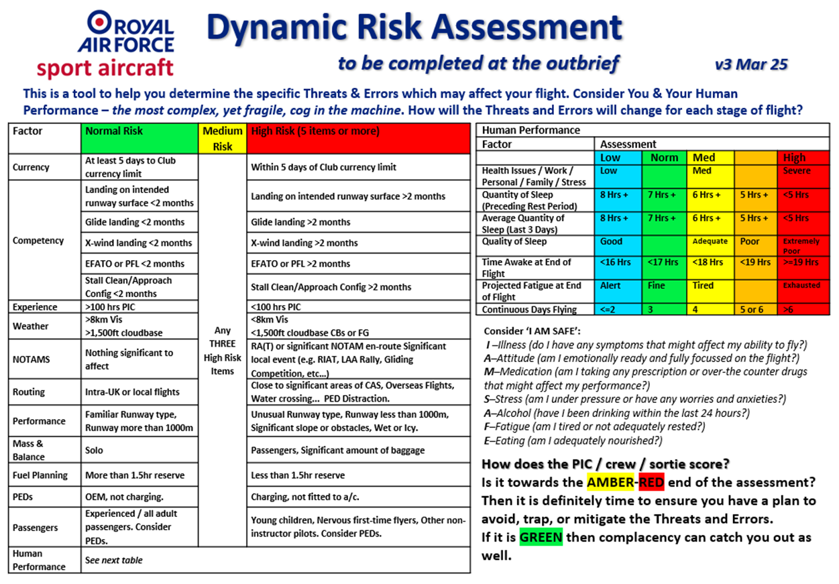

Annex C to RAFSA ASMP. The RAF Sport Incident Management Order and Notification Flow Diagram.
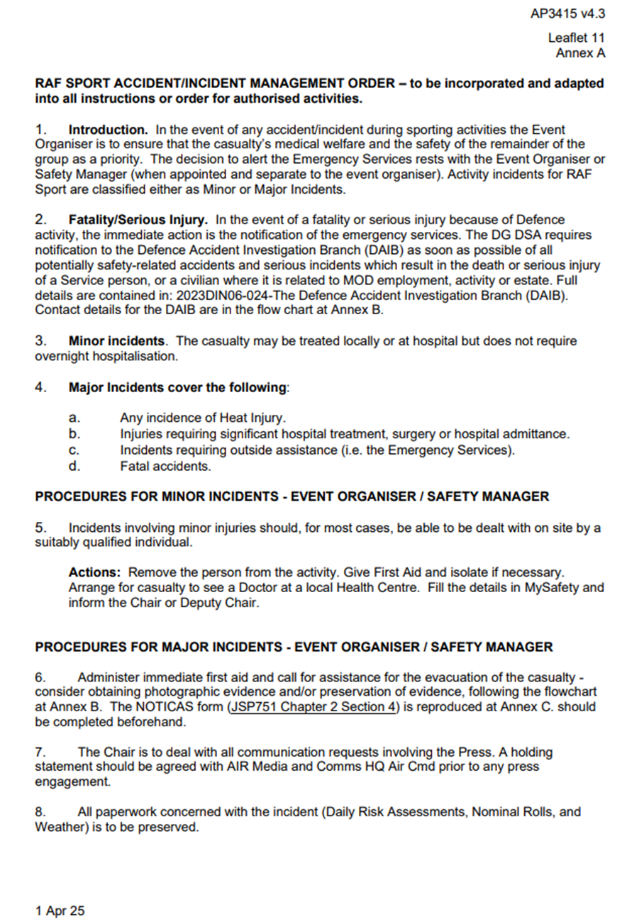
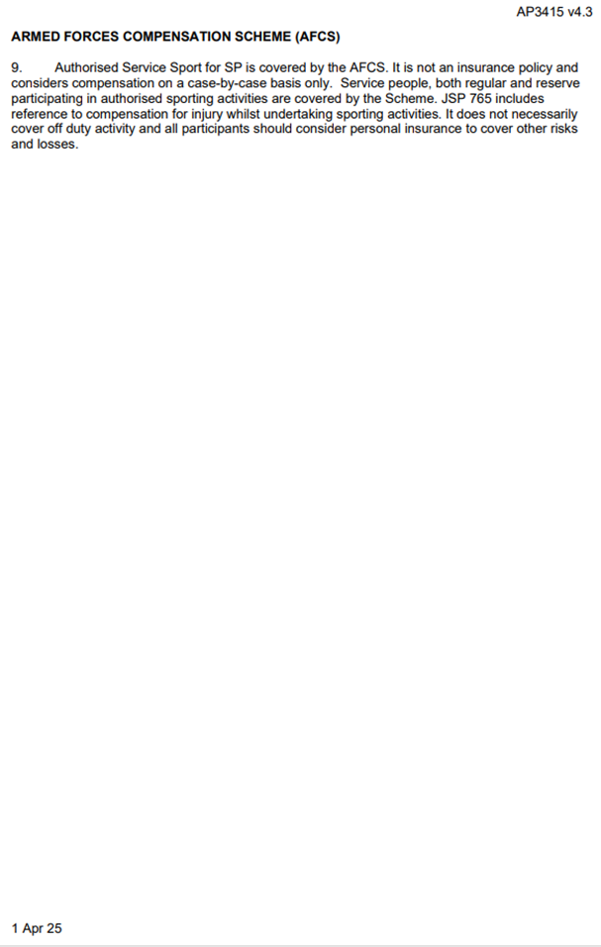
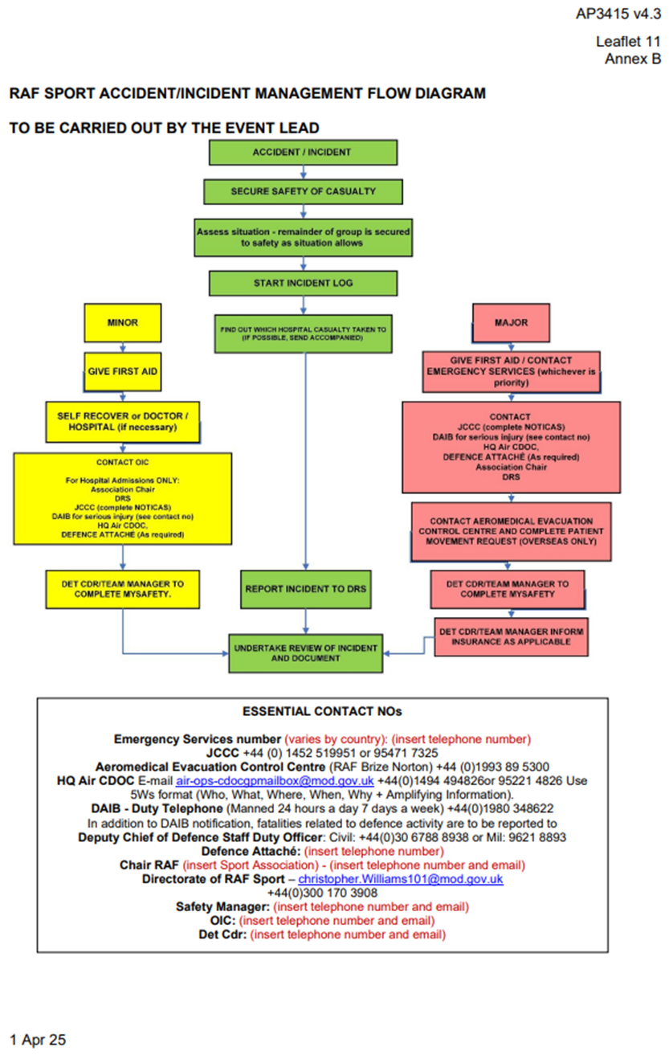
Note: current RAFSA Exec & Safety tel numbers are available, via the internet, at
https://rafsa-safety.jimdosite.com and via RAFSA-Safety@outlook.com

Annex D to RAFSA ASMP. FAiR model, as outlined in the MAA Manual of Air Safety.
